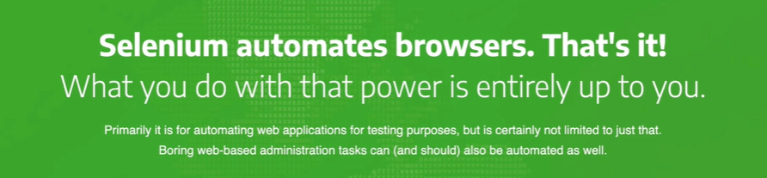

Selenium WebDriver

free tool and it basically allows us to automate the browser,get the browser to do things automatically

depending on a script or a piece of code that we write. Now,this is going to enable us to type as well as click as well as scroll.Basically anything that a human pretty much can do on a website, you can do using

a Selenium driven browser.It's kind of like we're building a robot and telling it what to do on a browser.And selenium is the tool that allows the robot to interact and communicate with the browser. And once we've leveled up,we'll be able to do all sorts of things like, for example,play web-based games like cookie clicker automatically to click on this cookie all by itself using the code instead of us having to manually do it and then to select upgrades and to purchase them, again, completely automatically.

If you ever wanted to be the best at cookie-clicker or any other web-based game and you don't want to invest the time in scaling up and getting good at it yourself, well then this is where automation might help you. But on a more serious note, you might use something like selenium to automate filling in forms or transferring information from an Excel spreadsheet to a online Google form, or basically doing anything that is repetitive and tedious, and you don't want to do it yourself.

<https://orteil.dashnet.org/cookieclicker/>

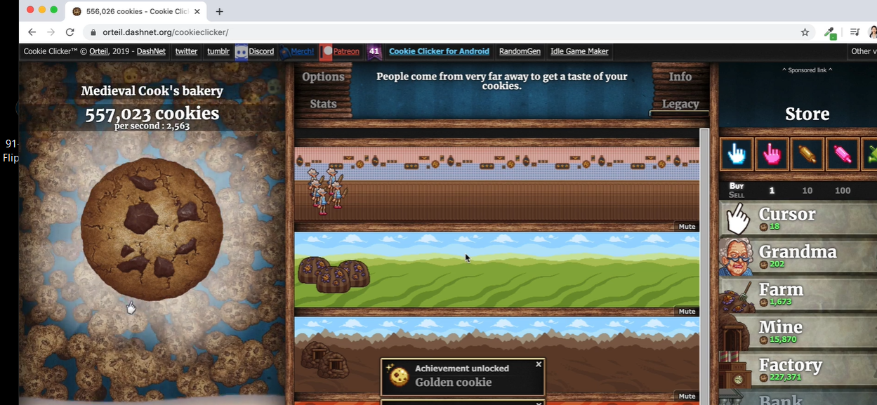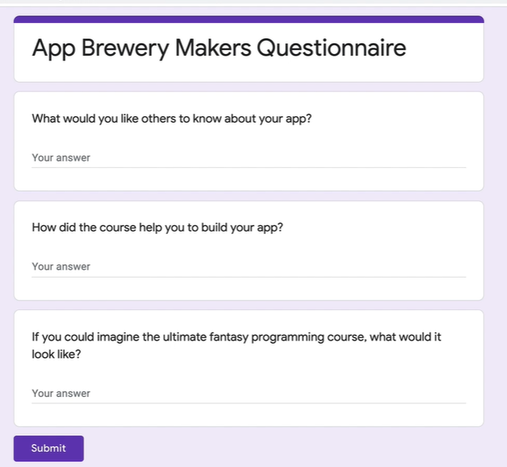

Set up browser and install browser – need chrome dev tools

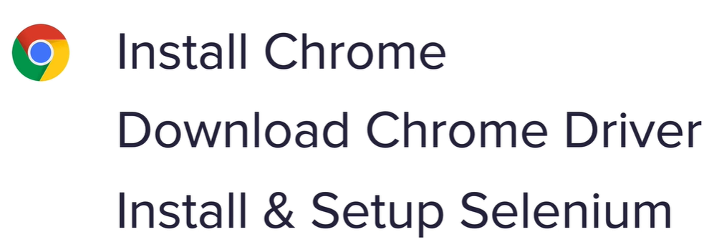

Downlode the chrome driver – match driver to version 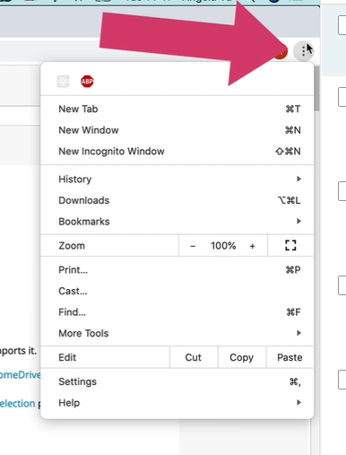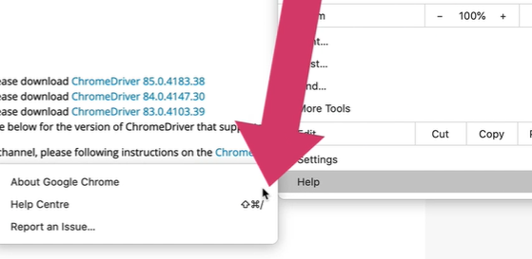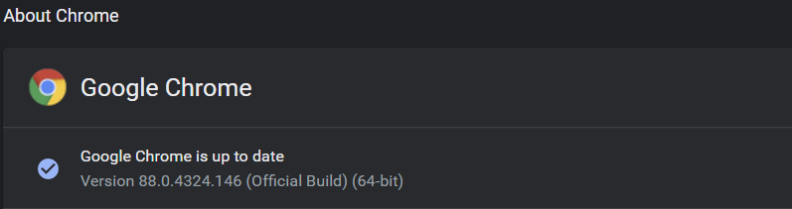

https://chromedriver.chromium.org/downloads

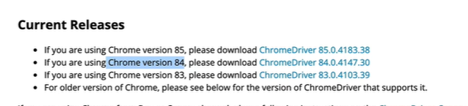

chrome_driver_path ="C:\Users\Hackathon\Documents\chromedriver_win32\chromedriver.exe"

import selenium

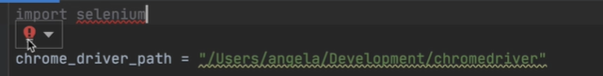

Then change import statement

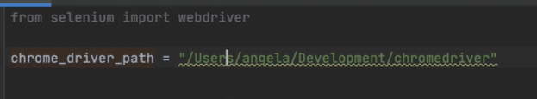

What is the Chrome driver >

We've got our Selenium package which contains code for us to be able to interact with browsers. Now it can interact with the Chrome browser which is what we're choosing to do,

but it can also interact with a bunch of other ones like Safari or Firefox.how do we make sure that this package which can handle all three knows specifically how to work with the Chrome browser? we're going to need some sort of a bridge that bridges the selenium code to work with the Chrome browser. And this bridge is provided by the Chrome driver.

So there'll be a different driver for a Safari,and there'll be a different driver for Firefox.And just by switching up those drivers,it will tell selenium how to work with the latest version of these browsers.All we have to do is now use it.

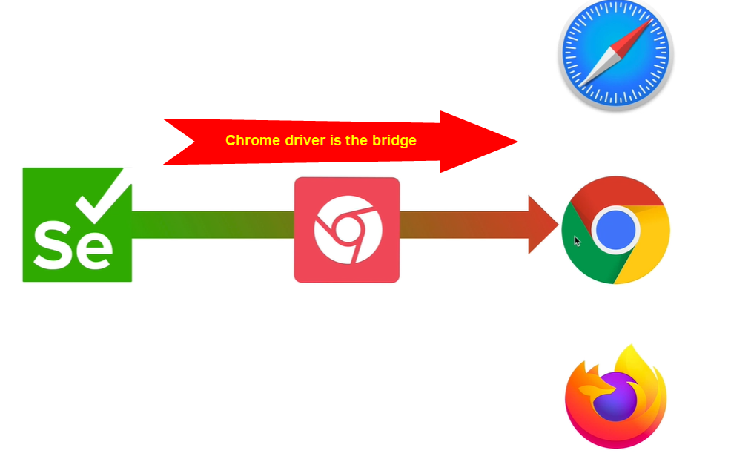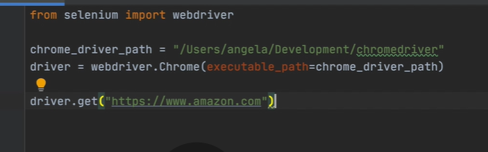

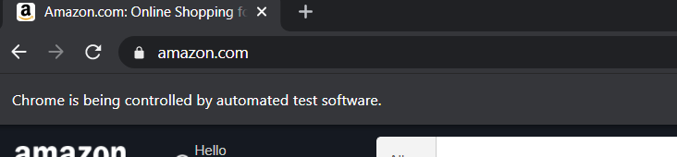

Find element by name, finding form name

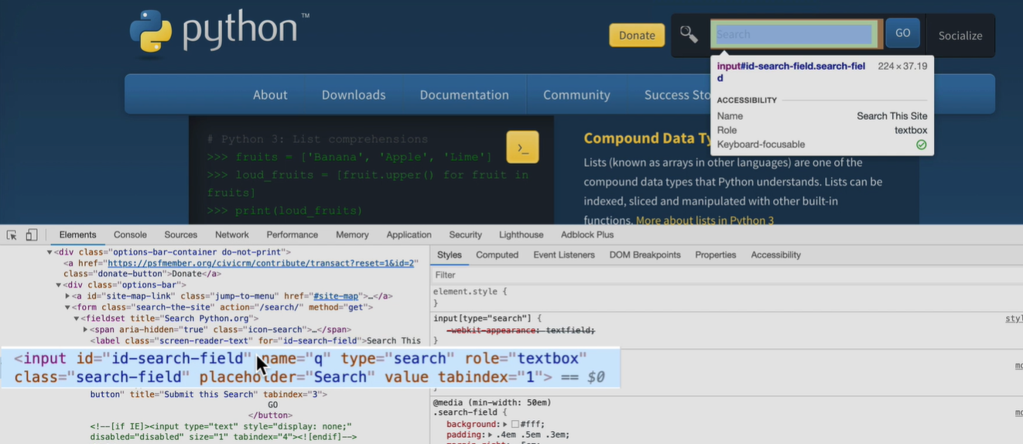

Very useful for filling out web forms

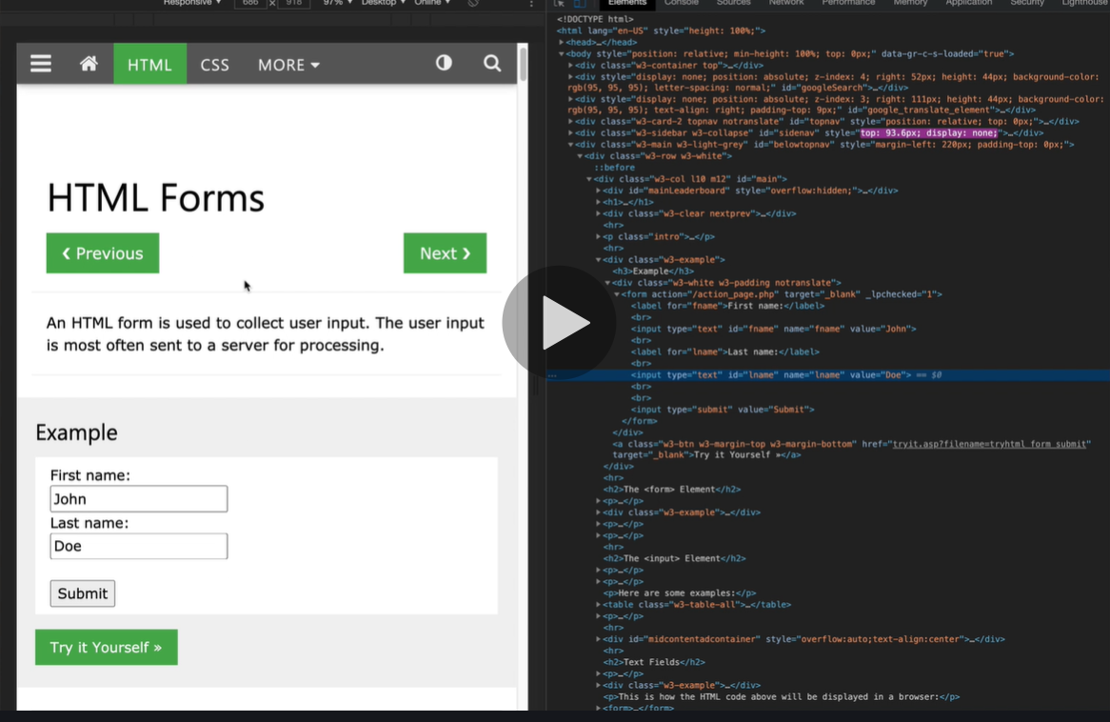

XPath

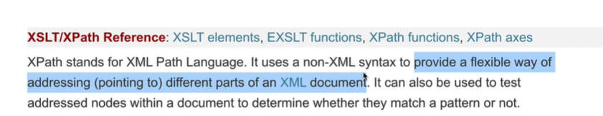

<https://www.w3schools.com/xml/xpath_intro.asp>

<https://developer.mozilla.org/en-US/docs/Web/XPath>

for Javascript -

<https://github.com/google/wicked-good-xpath>

in chrome dev tools right click and copy the xpath

//*[@id="container"]/li[8]/ul/li[2]/a

Locating elements with selenium

<https://selenium-python.readthedocs.io/locating-elements.html>

Scrapeing Wikipedia main page

<https://en.wikipedia.org/wiki/Main_Page>

cookie cutter game

<https://orteil.dashnet.org/cookieclicker/>

vs

http://orteil.dashnet.org/experiments/cookie/

Challenge: Create an Automated Game Playing Bot

1. Go to the game website and familiarise yourself with how it works:

<http://orteil.dashnet.org/experiments/cookie/> (classic version)

2. Create a bot using Selenium and Python to click on the cookie as fast as possible.

3. **Every** **5 seconds**, check the right-hand pane to see which upgrades are affordable and purchase the **most expensive one**. You'll need to check how much money (cookies) you have against the price of each upgrade.

e.g. both Grandma and Cursor are affordable as we have 103 cookies, but Grandma is the more expensive one, so we'll purchase that instead of the cursor.

HINT 1: <https://www.w3schools.com/python/ref_string_split.asp>

HINT 2: <https://www.w3schools.com/python/ref_string_strip.asp>

HINT 3: <https://www.w3schools.com/python/ref_string_replace.asp>

HINT 4: <https://stackoverflow.com/questions/13293269/how-would-i-stop-a-while-loop-after-n-amount-of-time>

4. After 5 minutes have passed since starting the game, stop the bot and print the "cookies/second". e.g. this is mine:

5. Once you've managed to get the bot to work, feel free to tweak the algorithm if you think there is a better way to play the game. e.g. Change the time, instead of every 5 seconds to check the upgrades, what if you did every second. Or maybe the bot should buy all the affordable upgrades. Post your algorithm in the Q&A and impress us all if you manage to get a higher cookies/second with your algo.